Lab 1 - Getting Started with RISC-V (Assembly Language) in VS Code

Name: Abdul Haseeb Khan | Student ID: 11146

Task 3:

Code:
main:
li x1, 5 # int a = 5;
li x2, 0 # int b = 0 + 0; (Fixed: assigned to x2 instead of read-only x0)
addi x1, x2, 32 # a = b + 32;

# int d = (a + b) - 5;
add x3, x1, x2 # temporary = a + b
addi x4, x3, -5

# int e = (((a - d) + (b - a)) + d);
sub x3, x1, x4 # temp1 = a - d
sub x6, x2, x1 # temp2 = b - a
add x7, x3, x6 # temp3 = temp1 + temp2
add x5, x7, x4 # int e = temp3 + d (e is in x5)

# e = a + b + d + e;
add x3, x1, x2 # temp4 = a + b
add x3, x3, x4 # temp4 = temp4 + d
add x5, x3, x5 # e = temp4 + e (updates e in x5)

end:
j end

Results:

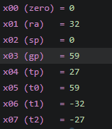

Explanation:

Translating basic math into assembly. I practiced turning high-level arithmetic expressions into RISC-V instructions like add, addi, and sub using standard register assignments.

Task 4a:
- Store x10 as unsigned integer at address 0x100.
addi x15, x0, 0x100
sw x10, 0(x15)

- Store x11 as unsigned integer at address 0x1F0.
addi x16, x0, 0x1F0
sw x11, 0(x16)

- Load an unsigned short integer (two bytes) from address 0x100 in x12.
lhu x12, 0(x15)

- Load a short integer from address 0x1F0 in register x13.
lh x13 , 0(x16)

- Load a singed character from address 0x1F0 in register x14.
lb x14, 0(x16)

Results:

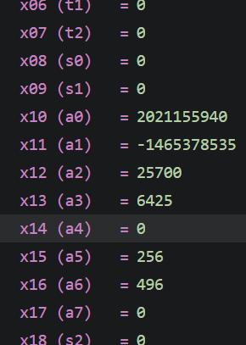
Explanation:
Working with memory addresses and data types. I wrote code to store values into specific RAM locations and load them back using various data widths like bytes and halfwords.

Task 4b:

Code:
li x20, 0x100 # Base address of array a
li x21, 0x200 # Base address of array b
li x22, 0x300 # Base address of array c

# i = 0
lb x5, 0(x20) # Load char a[0]
lh x6, 0(x21) # Load short b[0]
add x7, x5, x6 # Add a[0] + b[0]
sw x7, 0(x22) # Store to int c[0]

# i = 1
lb x5, 1(x20) # Load char a[1]
lh x6, 2(x21) # Load short b[1]
add x7, x5, x6 # Add a[1] + b[1]
sw x7, 4(x22) # Store to int c[1]

# i = 2
lb x5, 2(x20) # Load char a[2]
lh x6, 4(x21) # Load short b[2]
add x7, x5, x6 # Add a[2] + b[2]
sw x7, 8(x22) # Store to int c[2]

# i = 3
lb x5, 3(x20) # Load char a[3]
lh x6, 6(x21) # Load short b[3]
add x7, x5, x6 # Add a[3] + b[3]
sw x7, 12(x22) # Store to int c[3]

Results:
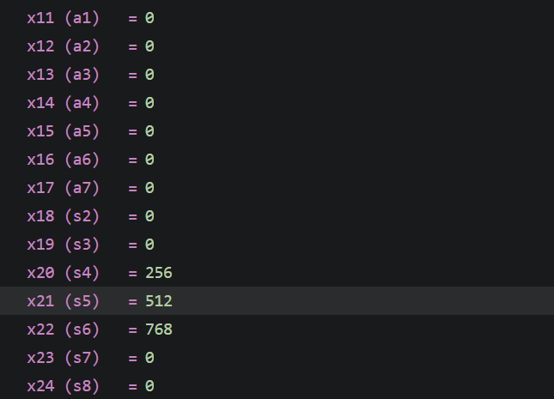

Explanation:

Unrolling a loop to handle arrays manually. Since loops hadn't been covered yet, I manually calculated the memory offsets to load character and short array elements, add them together, and store the results into an integer array

Assessment Rubric
Lab 1: Getting Started with RISC-V (Assembly Language) n VS Code

Name Abdul Haseeb Khan | Student ID: 11146 | Section: T-3

Points Distribution:

 | Task No. | LR 2 (Code) | LR 5 (Results)
In-Lab | Task 1 | - | /15
In-Lab | Task 2 | - | /15
In-Lab | Task 3 | /10 | /5
In-Lab | Task 4a | /10 | /5
In-Lab | Task 4b | /10 | /10
Total Points: 100 |  | /30 | /50
CLO Mapped |  | CLO 2

Affective Domain Rubric |  | Points | CLO Mapped
AR7 | Report Submission & Git Upload | /10 & /10 | CLO 2

CLO | Total Points | Points Obtained
2 | 100
Total | 100

